Resource Pack for the Economics Curriculum (S4-S6)

Economic Analaysis of China-US Trade War

Personal, Social and Humanities Education Section
Curriculum Development Institute
Education Bureau
2020
Preface
The China-US Trade War brings about various degrees of impacts on different places in the world. The Education Bureau publishes this resource pack to support the learning and teaching of the concepts related to the trade war in the Economics (S4-6). The Pack includes the analysis of the background, timeline and economic impacts on different areas of the trade war. The last section of the Pack introduces websites containing data concerning the trade war and reference books about the economic relationship between the US and Japan.

It is our honour to have Dr. Lee Shu Kam, Director of Business, Economic and Public Policy Research Centre, Hong Kong Shue Yan University to develop this resource pack for the Education Bureau.

The primary users of this resource pack are teachers and students. Teachers may provide appropriate supplementary notes/explanations or arrange students’ pre-lesson/extended learning activities to meet the learning and teaching needs. Teachers are welcome to share suggestions for improvement, and provide updated information to enrich the content for all teachers’ reference. If you have any comments or suggestions about this Pack, please send them to:

Chief Curriculum Development Officer (Personal, Social and Humanities Education) 1
Curriculum Development Institute
Education Bureau
Room 1319, 13/F., Wu Chung House
213 Queen’s Road East, Wanchai, Hong Kong
E-mail: info_pshe@edb.gov.hk

Contents
Contents | Page
Section I: Background
i. The Chinese yuan - US dollar Exchange Rate Issues | 1-2
ii. Before the “Trade War” | 2-3
iii. The Start of “Trade War” | 4-5
iv. Timeline of the China-US Trade War | 6-14
Section II: Impacts of the Trade War
i. Impacts on US import and domestic market | 15
ii. Decline in bilateral trade | 16-17
iii. Higher prices for consumers | 17-18
iv. Trade diversion effects | 18-19
v. Effects on US trade deficit | 19
vi. Macroeconomic Impacts | 20
vii. Impacts on the US’s price level | 20-21
Section III. Selected Information for the Topic and Q&A | 21-24
Reference Websites for this Topic | 25
Further Reading | 26
References | 27-28

The China-US Trade War
Section I: Background
At a World Economic Forum meeting in Switzerland in 2017, the Chinese President re-affirmed his country’s commitment to free trade and pledged never to start a protectionist ‘trade war’ or to benefit from a devaluation of its currency, the yuan. Meanwhile, the United States (US) President stated that the ‘America First’ doctrine means increased protectionism and he repeatedly threatened to impose tariffs and import quotas on Chinese goods.,

- The Chinese yuan - US dollar Exchange Rate Issues
During 2016, value of the US dollar rose against most currencies. In contrast, the Chinese yuan weakened significantly from 6.20 yuan per US dollar at the end of 2014 to 6.95 yuan at the end of 2016.
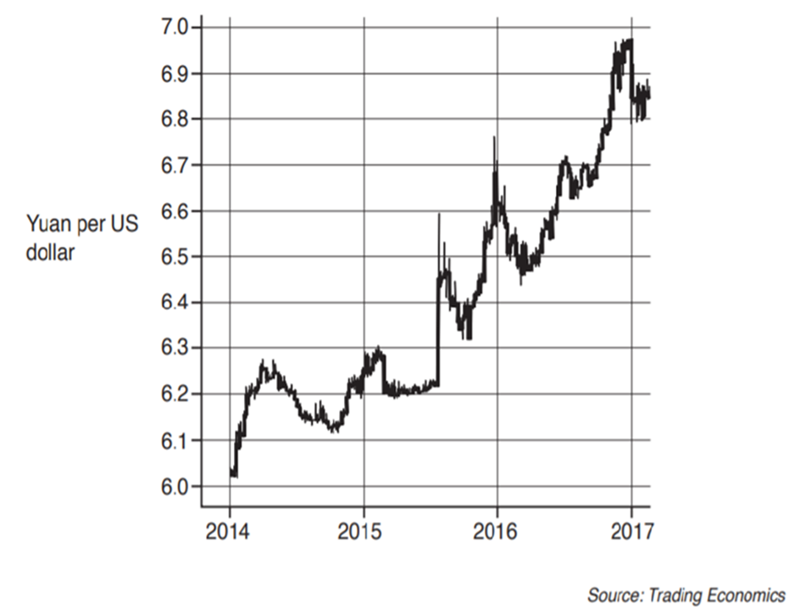
The US President has accused China of intentionally devaluing the yuan to boost China’s export competitiveness. Despite strong downward pressure on its currency, China has attempted to keep the yuan–US dollar exchange rate relatively stable, costing more than US$2 trillion of its official foreign exchange reserves. China has stated that it does not want the yuan to fall in value any more than the US does. Nevertheless, no country has complete control over its exchange rate.

Analogous to Japan and Germany, China typically has a current account surplus on the balance of payments. However, China’s current account surplus as a percentage of GDP fell in 2016 and the International Monetary Fund expects it to decrease further, as exports continue to fall.

There are three policy paths for a country’s exchange rate: a completely free float, a managed float, or a fixed (pegged) exchange rate. Each of these strategies has various advantages and disadvantages. At present, China’s exchange rate policy is a managed float. However, some economists argue that stability of the yuan–US dollar exchange rate is especially important and preferably for China to fix (peg) the yuan to the US dollar.

- Before the “Trade War”
The US government has accused China of causing a huge trade deficit over the US. In 2007, value of the export from China was US$ 477 billion and value of the export from the US to China was US$ 140 billion. As such, US has a trade deficit of US$ 337 billion against China.

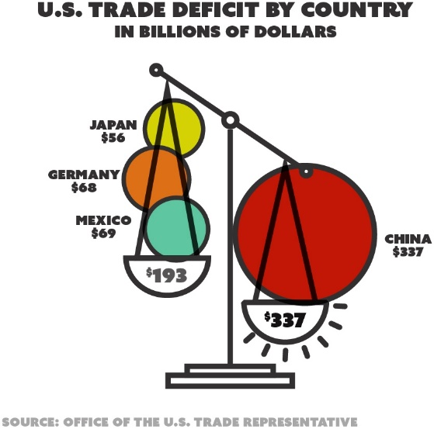
After Donald Trump has taken office, the White House took a tough stance on trade policies even before the outbreak of the China-US trade war. In June 2017, Trump initiated a ‘Section 232 investigation’, for national security reason, on the import of steel and aluminium. Considering the huge production capacity of steel and aluminium in China, this investigation and the resulting additional tariff was believed to be targeting primarily on China.

Since 2018, trade disagreements between the US and China have increased in scale and frequency. The US has repeatedly imposed anti-dumping duties or tariffs on imports from China. Trade tensions escalated in March 2018 when US President Donald Trump signed an executive memorandum launching a ‘Section 301 investigation’ into China’s intellectual property practices and threatened with extra tariffs on Chinese imports.

In retaliation, China promptly issued a similar statement on the next day, reciprocating the threats with warnings of additional tariffs on American imports. On 4 April 2018, the US detailed a list of 1,333 Chinese goods, valued at US$ 50 billion, to be subject to an additional 25% tariff. China retaliated immediately with reciprocal tariffs on a list of American goods of equal value, matching threats from the US on a dollar-for-dollar basis.
- The Start of “Trade War”
Liu He, the vice-premier of the People’s Republic of China, led a Chinese delegation to the US on 17 May 2018. They met the US president, Donald Trump, and went through several rounds of negotiations with the US trade officials, including Steven Mnuchin, Wilbur Ross, and Robert Lighthizer. A joint declaration was announced subsequently, reflecting a cooperative attitude from both sides to reach a temporary easing of trade tensions. However, on 16 June, the Office of the United States Trade Representative (USTR) announced a US$ 50 billion tariff list, covering over 1,000 Chinese goods. In response, China’s Customs Tariff Commission of the State Council issued a notice immediately, announcing tariffs on 659 locally-manufactured American goods valued at US$ 50 billion. At the same time, the Ministry of Commerce declared that previous negotiation attempts with the US had failed, marking the official start of the China-US Trade War.

After several rounds of ministerial-level negotiations, Xi Jinping, the general secretary of the Communist Party of China, met with Donald Trump at the 2018 G20 Summit in Buenos Aires. Both parties agreed on suspending the new trade tariffs for 90 days to facilitate continuing negotiations. However, the ceasefire was believed to be a temporary truce, as further actions may be taken by either side if substantive agreements cannot be reached during this negotiation window. Since then, future of the trade conflict remains unclear.

The trade war originated when the US President Donald Trump signed a memorandum on March 22, 2018, ordering the US trade representatives to impose tariffs on imported goods from China, with a total estimated value of US$ 60 billion. On July 6, 2018, the United States imposed an additional 25% tariff on Chinese exports worth US$ 34 billion. In response, the Ministry of Commerce of the People’s Republic of China made countermeasures on the same day and imposed a 25% additional tariff on imports from the US worth US$ 34 billion, including soybean. The different stages of the Trade War are summaried in the following timeline.
Note: The China-US Trade War continues when this resource pack is published on 19 November 2020.

- Timeline of the China-US Trade War

The timeline information is adopted from the following sources:
https://www.reuters.com/article/us-usa-trade-china-timeline/timeline-key-dates-in-the-us-china-trade-war-idUSKCN1VD20A
https://www.china-briefing.com/news/the-us-china-trade-war-a-timeline/
https://www.bloomberg.com/news/articles/2020-09-15/wto-rules-that-u-s-tariffs-on-china-violate-trade-rules-kf4189y0

Section II: Impacts of the Trade War
- Impacts on US import and domestic market
Diagram (a) Diagram (b)
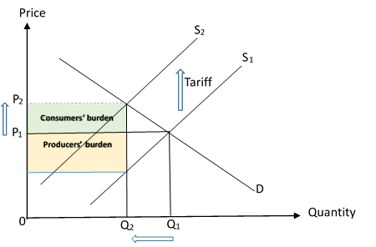
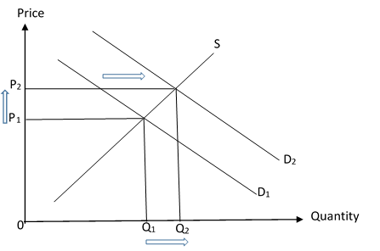
Demand and supply for import
Demand and supply for domestic product

The impact of tariff on the market of imported goods in the US is shown in Diagram (a). For simplicity, the tariff is assumed to be per-unit, and the supply curve shifts upward as a result of tariff imposition. Price of the Chinese imports will increase and hence the quantity demanded for import will decrease. Share of the tax burden between buyers and sellers will depend on the price elasticity of the demand and supply for imports.

Diagram (b) shows the change in the market of domestic goods after the imposition of the tariff. Since the domestically produced goods and the imported goods are substitutes, demand for domestic goods will increase and the demand curve shifts to the right. This drives up the prices of imported goods and domestic goods for the local consumers.

Remark: On the other hand, foreign suppliers receive lower price and produce less. Unemployment may result in the exporting countries.
- Decline in bilateral trade
If the exporting country retaliates, bilateral trade would decline and both countries would lose consequently. Both of these two countries would seek other sources of imports to avoid the tariffs. In this scenario, other economies that take over as new sources of imports would gain.

According to the International Monetary Fund (IMF) and United Nations Conference on Trade and Development (UNCTAD) Studies, under the trade war between the US and China, US imports from China declined in all the three groups of goods on the tariff lists.
US imports from China
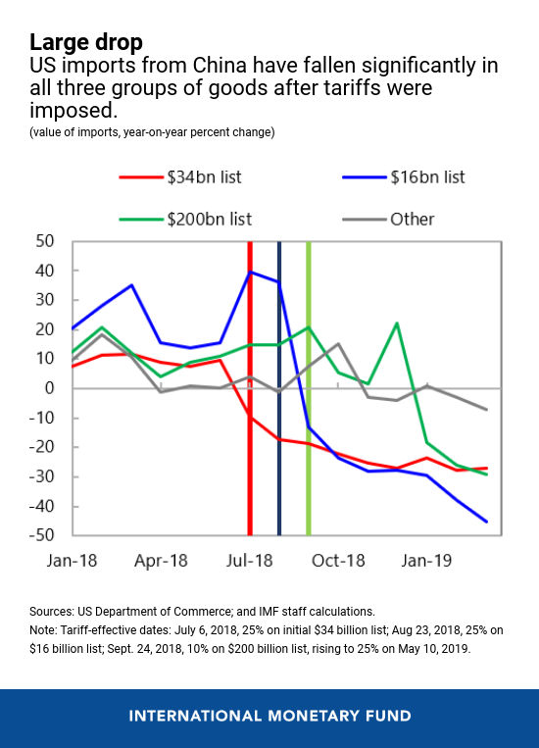
Adopted from: IMFBlog - https://blogs.imf.org/2019/05/23/the-impact-of-us-china-trade-tensions/

At the same time, US exports to China also declined as China imposed retaliatory tariffs.
US exports to China
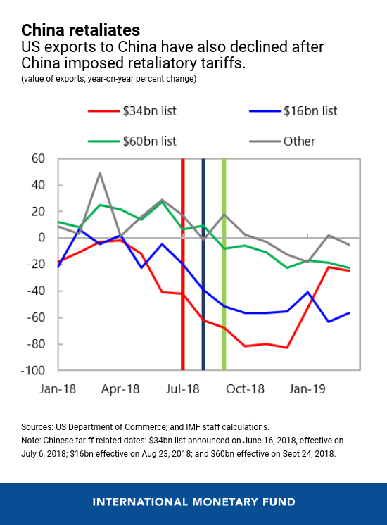
Adopted from: IMFBlog - https://blogs.imf.org/2019/05/23/the-impact-of-us-china-trade-tensions/

- Higher prices for consumers
Prices of imports in US
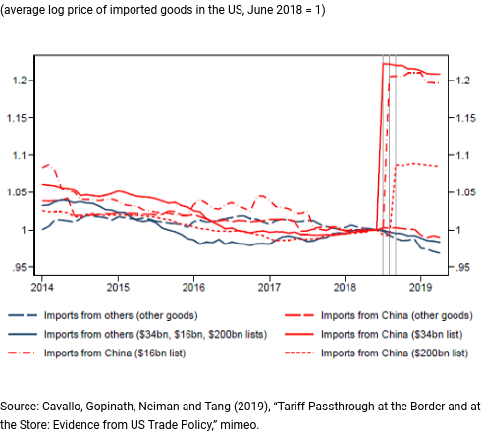
Adopted from: IMFBlog - https://blogs.imf.org/2019/05/23/the-impact-of-us-china-trade-tensions/

As shown in the above figure, there was a sharp jump in the post-tariff import prices matching the magnitude of the tariff. However, there was little change in the ex-tariff border prices of imports from China. This implies that the US tariffs on China have been paid almost entirely by the US importers, manufacturers or consumers (in the short-run). But, it was observed that Chinese firms had recently started absorbing part of the costs of the tariffs by reducing the prices of their exports.

- Trade diversion effects
Changes in imports in US
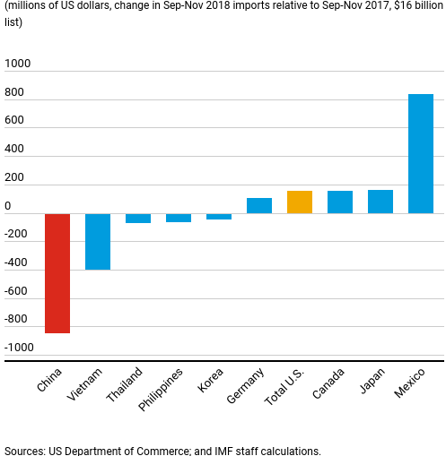
Adopted from: IMFBlog - https://blogs.imf.org/2019/05/23/the-impact-of-us-china-trade-tensions/

As shown in the above figure, decline in the imports from China to the US was offset by an increase in imports from other countries (Mexico in particular). The potential winners under the trade war are local producers competing in domestic markets with imports affected by tariffs and third-country exporters. While the potential losers under the trade war are importers adversely affected by the tariffs and local producers that use those tariffed goods as intermediate inputs.

- Effects on US trade deficit
US trade deficit
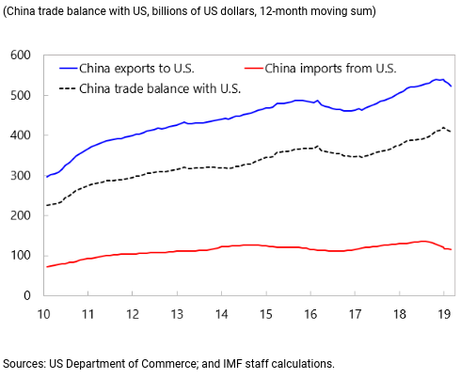
Adopted from: IMFBlog - https://blogs.imf.org/2019/05/23/the-impact-of-us-china-trade-tensions/

The above figure illustrates the trade pattern between the US and China for the period 2010 to 2019. The tariffs imposed by the US on imports from China have little effect on the US trade deficit against China. Some economists suggest that macroeconomic factors, e.g. the relative aggregate demand and supply in partner countries and their underlying drivers, play a much bigger role than tariffs in determining the bilateral trade balances.

- Macroeconomic Impacts
Both countries would experience a decrease in sales, which in turn put pressure on total output and employment in the short run. An increase in the import price decreases the SRAS as a result of higher production costs and the SRAS curve shifts to the left. Besides, the wealth effect of a fall in value of the stock market might decrease the consumption expenditure, and the fall in stock price might also dampen the investment incentive, and the investment expenditure decrease. As a result, the AD decreases and shifts to the left, real output decreases and unemployment increases. When the magnitude of the shift in SRAS is greater than that of the AD, the general price level will increase.

- Impacts on the US’s price level
The US CPI for Major Appliances
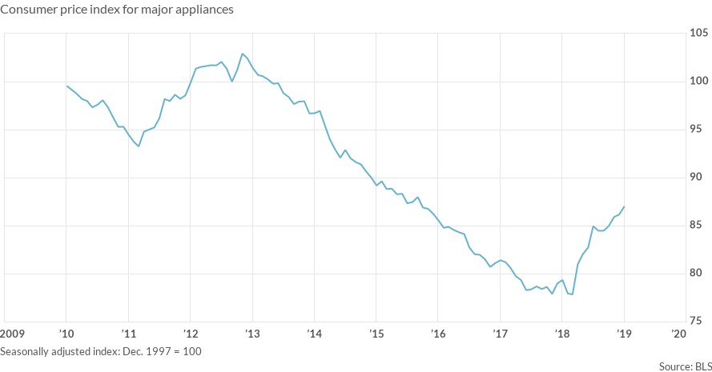
The US CPI
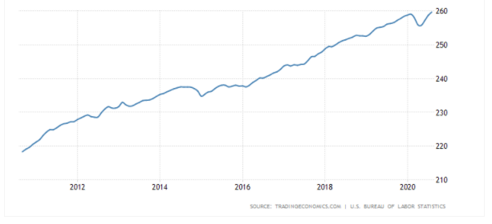
To measure impacts of the trade war on the US price level, CPI for the major appliance is a better indicator of import price of goods than that of the overall CPI, which included prices of the non-tradable goods. Before the US-China trade war, CPI in the US for the major appliance was decreasing. After imposing the tariff, this trend changed to be increasing.

Section III: A case study in relation to the US-China Trade War—Soybean
- Before Trade War
Before 2018, China was the world’s largest importer of soybeans from the US. Soybean is used as the raw material for soybean oil and main pig feed. The U.S. soybean was one of the products which tariff was charged. China’s demand for pork meat makes up nearly half of the world’s total output. For an average Chinese family, pork accounts for two-thirds of their meat consumption, and on average, a Chinese person consumes 120 pounds of pork annually. China is almost self-sufficient in terms of pork supply.

- Trade War begins
On March 22, 2018, the US imposed tariffs on imported goods from China, totalling an estimated value of US$ 60 billion. Imposition of an additional 25% tariff on Chinese exports worth US$ 34 billion on July 6, 2018. In response, the Ministry of Commerce of the People’s Republic of China made countermeasures on the same day and imposed a 25% additional tariff on the US exports worth US$ 34 billion, including soybean. Figure 1 shows that soybean imported from the US to China dropped to almost zero in November 2018.

Figure 1: Soybean Shipments to China
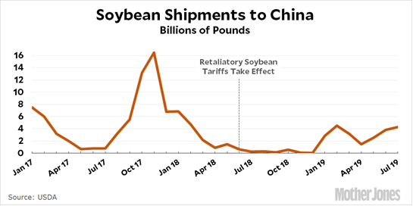
Source: https://www.motherjones.com/kevin-drum/2019/08/china-is-buying-lots-of-us-soybeans/

According to the General Administration of Customs of the PRC, in the first two quarters of 2020, China’s import volume of the US soybean has been restored to the level before the trade war.

- Possible relation to African swine fever virus
Uncooked food scraps are the substitute for soybean for feeding pigs. Unfortunately, sourcing of the uncooked food scraps were infected with African swine fever (ASF) virus. The first ASF outbreak happened in August 2018 in Shenyang, northeastern China, and spread rapidly in China. To counteract further spread, the Chinese government killed more than 100 million pigs within one year. The total output (supply) of pork dropped approximately one-third of the total. With a traditional high demand for pork, pork price rose as a consequent.

Figure 2: Pork price in China
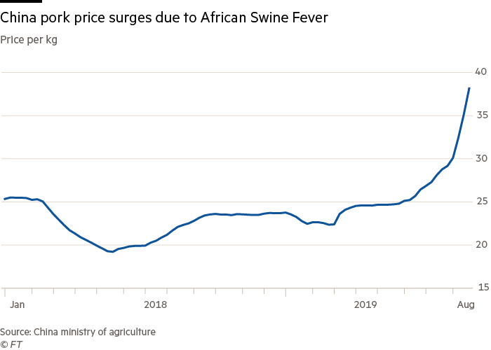

- Suggested questions for further enquiries
1. Refer to Figure 1 above, explain the effects of China’s retaliatory soybean tariff on the quantity and price of US soybean in China with a supply-demand diagram.

Ans: After imposing tariff on the US soybean, quantity of the imported US soybean decreased (import volume of the US soybean to China in November 2018 dropped to almost zero), and price of the US soybean increased in China as a result.
US imported Soybean in China
2. Refer to Figure 2 above, suggest one condition that total spending on pork in China increased from January to August 2019.

Ans: When the price elasticity of demand for pork is inelastic in China, the percentage increase in price would be greater than the percentage decrease in quantity demanded. The total expenditure would increase.

*3. Refer to the information given in Parts I, II and III above, discuss why the trade war might speed up the spread of ASF in China.

Ans: Given one of the common uses of soybean is in pig feed. When China imposed the tariff on soybean imported from the US, the soybean price would rise, and the cost of using soybean as pig feed increased in China. Farmers hence used uncooked food scrap as a substitute to feed the pigs. When the uncooked food scraps were adversely infected with virus, pigs would suffer from the ASF. In short, price of the imported soybean from US increased due to the retaliatory tariff under the Trade War. Consequently, farmers shifted to uncooked food scraps for pig feed to substitute the soybean. Therefore, when the scraps were infected, the pigs would also be infected from ASF.

*This question requires students to synthesize all the information given and make a logical deduction with economic concepts.

Reference Websites for this Topic
Bloomberg | www.bloomberg.com
International Monetary Fund | www.imf.org
Ministry of Commerce of the People’s Republic of China | www.mofcom.gov.cn
National Bureau of Statistics of China | www.stats.gov.cn
Reuters | www.reuters.com
The Asian Development Bank | www.adb.org
The Asian Infrastructure Investment Bank | www.aiib.org
The World Bank | www.worldbank.org
Trade and Industry Department, The Government of the Hong Kong Special Administrative Region | www.tid.gov.hk/english/trade_relations/us/us_mainland_trade_conflicts.html
U.S. Bureau of Economic Analysis | www.bea.gov
U.S. Bureau of Economic and Business Affairs | www.state.gov/bureaus-offices/under-secretary-for-economic-growth-energy-and-the-environment/bureau-of-economic-and-business-affairs
U.S. Bureau of Labor Statistics | www.bls.gov
U.S. Census Bureau | www.census.gov
U.S. Department of Commerce | www.commerce.gov

Further Readings
 | Title: The History of US-Japan Relations From Perry to the Present  Year: 2017  Authors: Makoto Iokibe and Tosh Minohara  Weblink:  https://www.palgrave.com/gp/book/9789811031830#aboutBook
 | Title: Charting a Path for a Stronger U.S.-Japan Economic Partnership  Year: February 14, 2019  Authors: Saori N. Katada, Junji Nakagawa, and Ulrike Schaede  Weblink:  https://www.nbr.org/publication/charting-a-path-for-a-stronger-u-s-japan-economic-partnership/

References
Baldwin, R.E. (1960), "The Effects of Tariffs on International and Domestic Prices", Quarterly Journal of Economics, 74(1) 65-70.
Bhagwati, J., V.K. Ramaswami and T.N. Srinivasan (1969), "Domestic Distortions, Tariffs, and the Theory of Optimum Subsidy: Some Further Results", Journal of Political Economy, 77(6) 1005-1013.
Carbaught, R. (2016). International economics. (15th ed.). South-Western.
Chong, T. T. L., & Li, X. (2019). Understanding the China–US trade war: causes, economic impact, and the worst-case scenario. Economic and Political Studies, 7(2), 185-202.
Economic Planning Agency (Keizai Kikaku-chō) 1986, ed., Shōwa 55-nen Kijun Kaitei Kokumin Keizai
Keisan Hokoku (Report on Revised National Accounts on the Basis of 1980), Ōkura-shō Insatsukyoku (Ministry of Finance Printing Bureau), Tokyo, vol. 1.
Feenstra, R. and Taylor, A. M. (2014). International economics. (3rd ed.). Worth Publisher.
Gerber, J. (2014). International economics. (6th ed.). Pearson.
Husted, S. and Melvin, M. (2013). International economics. (9th ed.). Pearson.
Meltzer, J. P., & Shenai, N. (2019). The US-China economic relationship: A comprehensive approach. Available at SSRN 3357900.
Krugman, P. R., Obstfeld, M., and Melitz, M. (2015). International economics: Theory and policy. (10th ed.). Pearson.
McConnell C. R., Brue S. L., & Flynn S. M. (2020). Economics: Principles, Problems, & Policies, 22nd ed., McGraw-Hill
OECD. (2013). Interconnected economies: Benefitting from global value chains. OECD.
Pugel, T. (2015). International economics. (16th ed.). McGraw Hill.
Riad A. Ajami (2020) US-China Trade War: The Spillover Effect, Journal of Asia-Pacific Business, 21:1, 1-3
Salvatore, D. (2013). International economics. (11th ed.). Wiley.
Urata,S. (2020). US–Japan Trade Frictions: The Past, the Present, and Implications for the US–China Trade War. Asian Economic Policy Review, Japan Center for Economic Research, vol. 15(1), pages 141-159, January.
Wang, Y. (2020), "Causes of U.S.-China trade imbalances: a review", Journal of Chinese Economic and Foreign Trade Studies, Vol. 13 No. 1, pp. 37-44.
Web sources
https://blogs.imf.org/2019/05/23/the-impact-of-us-china-trade-tensions/#:~:text=US%2DChina%20trade%20tensions%20have,trade%20deficit%20remains%20broadly%20unchanged
https://unctad.org/en/pages/newsdetails.aspx?OriginalVersionID=2226
https://www.investopedia.com/trading/chinese-devaluation-yuan/
https://outsourceworkers.com.au/offshoring-and-outsourcing/
https://www.economicsonline.co.uk/Global_economics/Trading_blocs.html
https://www.thebalance.com/trade-wars-definition-how-it-affects-you-4159973
https://www.reuters.com/article/us-usa-trade-china-timeline/timeline-key-dates-in-the-us-china-trade-war-idUSKCN1VD20A
https://www.china-briefing.com/news/the-us-china-trade-war-a-timeline/
https://news.cgtn.com/news/2019-07-11/Lessons-from-U-S-Japan-trade-war-of-1980s-IcWJh9RjAQ/index.html

Parker, C. (2017). China's Xi Jinping defends globalization from the Davos stage. World Economic Forum. https://www.weforum.org/agenda/2017/01/chinas-xi-jinping-defends-globalization-from-the-davos-stage/
BBC News. (10 May 2019). Trade wars, Trump tariffs and protectionism explained. https://www.bbc.com/news/world-43512098
BBC News. (6 August 2019). Yuan fall: Why is China's currency getting weaker? https://www.bbc.com/news/business-49245654
Adopted from, Cambridge International Advanced Subsidiary and Advanced Level, Cambridge Assessment International Education. May/ June 2019.
Chong, T. T. L., & Li, X. (2019). Understanding the China–US trade war: causes, economic impact, and the worst-case scenario. Economic and Political Studies, 7(2), 185-202.
The White House. (11 October 2019). Remarks by President Trump and Vice Premier Liu He of the People’s Republic of China in a Meeting. https://www.whitehouse.gov/briefings-statements/remarks-president-trump-vice-premier-liu-peoples-republic-china-meeting/
Section 201 of the US Trade Act of 1974—allows the President to impose temporary duties and other trade measures if the International Trade Commission (ITC) determines a surge in imports is a substantial cause or threat of serious injury to a U.S. industry.
Section 232 of the Trade Act of 1962 authorizes the President to impose imports restrictions on products, imported into the United States “in such quantities or under such circumstances as to threaten to impair the national security”.
Section 301 of the US Trade Act of 1974— authorizes the President to take all appropriate action, including tariff-based and non-tariff-based retaliation, to obtain the removal of any act, policy, or practice of a foreign government that violates an international trade agreement or is unjustified, unreasonable, or discriminatory, and that burdens or restricts U.S. commerce.
Major Appliances contains refrigerators, freezers, dishwashing machines, washing machines, cookers, and ovens. Consumers electronics and appliances for professional usage are not included in this segment.

